**Project REST**

*This document will serve as our primary reference point. It should be detailed and well-structured, ensuring that anyone—regardless of when they join the project—can easily understand our objectives, progress, and workflow. It will outline our technical decisions, research findings, implementation steps, and future plans, making it a comprehensive guide for all team members.*

**Overview**

As a consulting organization specializing in data-driven solutions, maintaining a competitive edge requires more than just client projects—it demands innovation and proof-of-concept development. Beyond advising businesses, we are committed to building deployable products that showcase our technical capabilities and demonstrate real-world applications of analytics and strategy. These initiatives allow us to develop market-ready solutions that can either be leveraged by businesses directly or serve as foundational prototypes for industry-specific tools.

Project REST is our pilot initiative in the **restaurant and hospitality** industry, a sector that heavily relies on customer reviews for reputation and growth but often lacks the technical infrastructure to effectively extract, analyze, and act on insights from these reviews.

Why this industry?

* High reliance on public perception: Online reviews significantly impact revenue and customer retention.
* Fragmented data landscape: Reviews are spread across multiple platforms (Google, Yelp, TripAdvisor, OpenTable, etc.), making consolidated analysis difficult.
* Limited technical expertise: Small-to-medium-sized businesses (SMBs) in this space often lack the in-house resources to apply natural language processing (NLP), sentiment analysis, or trend forecasting.
* Aging leadership & slow tech adoption: Many restaurant owners/operators rely on intuition rather than data, leading to missed opportunities and suboptimal decision-making.

We are developing a full stack integrable tool that scrapes data from multiple review websites, apps, and other sources, then applies natural language processing to understand how customers feel about products and services in a given restaurant or business that rely heavily on online review.

**This Will Include:**

* Automated sentiment analysis of online reviews
* Visualization/reporting to highlight trends and customer perceptions
* Market research component summarizing current trends among small-to-medium business restaurants, along with insights from expert interviews
* Etc...

**Bigger Picture**

By consolidating reviews from multiple channels, the businesses a clear, consolidated snapshot of how they are perceived by customers. This could help them with the following:

* Identify areas of **improvement** or success (e.g., service speed, menu items, ambiance)
* Compare their performance to others in the market
* Spot emerging trends and seasonal preferences
* Highlight unique selling points

**Major Project Phases**

|  |  |  |
| --- | --- | --- |
| **Phase** | **Key Deliverables** | **Estimated Completion** |
| Research & Discovery | - Explore relevant literature and best practices around NLP and sentiment analysis.  - Investigate potential APIs and data sources (Yelp, Google Places, TripAdvisor, OpenTable).  - Conduct general research about web scraping, NLP models, and competitive solutions. | Week 1 - 2 |
| Planning & Design | - Define project scope and requirements (data volume, features, timelines).  - Map out the technology stack and architecture (tools, frameworks, hosting).  - Clarify team roles, responsibilities, and key milestones. | Week 2 - 3 |
| Data Collection & Scraping | - Implement web scraping and API integrations to gather reviews.  - Store raw data in a structured and secure environment.  - Ensure compliance with API usage limits, legal considerations, and ethical guidelines. | Week 3 - 5 |
| Development & Testing | - Build out the core NLP components for sentiment analysis.  - Implement data visualization and reporting features.  - Conduct iterative testing (unit tests, user acceptance tests) and refine the product. | Week 5 - 10 |

**Visualization Of Project:**

To be created...

**GitHub:**

|  |  |  |  |
| --- | --- | --- | --- |
| **First Name** | **Last Name** | **NetID** | **GitHub Username** |
| Farhan | Mashrur | fm454 | fm454 |
|  |  |  |  |
|  |  |  |  |
|  |  |  |  |
|  |  |  |  |
|  |  |  |  |

Note: Add rows as needed abovee

You will need to be familiar in GitHub to work effectively on this project. Here are some resources to help you learn more:

* Github [docs](https://docs.github.com/en/get-started/start-your-journey/hello-world)
* How to use Git and GitHub YouTube [*link*](https://www.youtube.com/watch?v=HkdAHXoRtos)
* What is git YouTube [*link*](https://www.youtube.com/watch?v=2ReR1YJrNOM)

**Meeting (2/20): Learning & Exploration**

**Intro to APIs**

* API stands for Application Programming Interface. In the context of APIs, the word Application refers to any software with a distinct function. Interface can be thought of as a contract of service between two applications. This contract defines how the two communicate with each other using requests and responses**. -AWS**
* **Suggested Resources (Optional)**
* What is an API [medium article](https://medium.com/@perrysetgo/what-exactly-is-an-api-69f36968a41f)
* How an API works [YouTube link](https://www.youtube.com/watch?v=s7wmiS2mSXY&pp=ygUOd2hhdCBpcyBhbiBhcGk%3D)
* **Questions to Consider**
  + What are some real-world examples of APIs you interact with daily?
  + Why do you think APIs are important in building full-stack applications?
  + What concerns might businesses have when exposing or using APIs?

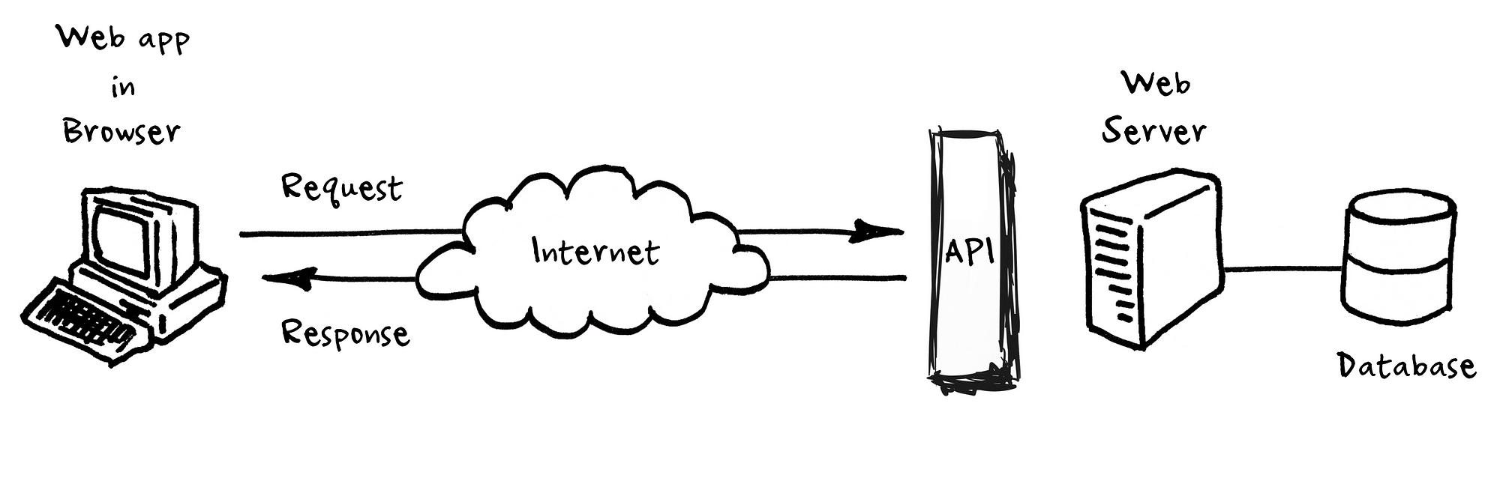

**Natural Language Processing (NLP)**

* TODO: Conduct research on what is NLP.
* TODO: Try to discover how NLP is used to extract meaning from text
* TODO: How exactly does it work? Maybe some visuals?
* TODO: What are the available libraries, what are pros and cons of using each?
* TODO: what are the industry standards when working with NLP?
* Additional notes

### **Web Scraping**

* **TODO:** Conduct research on what web scraping is.
* **TODO:** Explore why web scraping is useful and where it is commonly used.
* **TODO:** How does web scraping work? Maybe find some visuals or examples.
* **TODO:** What are the most popular web scraping libraries? What are the pros and cons of each?
* **TODO:** What are the ethical and legal considerations when scraping data?
* **TODO:** Are there any industry best practices for responsible web scraping?

Notes:

**Project Leads**

* **Ahmed Abdulla (aaa384)**

**Questions?** Reach out to Ahmed (aaa384)